DOCUMENT 29 — Growth, Referral & Word-of-Mouth Engine
Visionary Internal · v1.0 · CAC ≈ 0 by design; the product is the channel

Growth comes from visible understanding: a shared project, a shared report, a teacher
who brings a school. Referral rewards learning outcomes, not invites-spam.

1. Loops
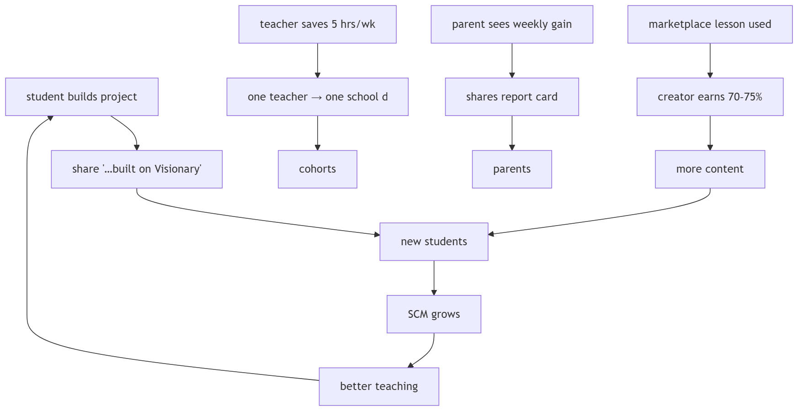

2. Referral mechanics
- Student↔student: both earn premium days on verified learning (referee completes
first verified-understand), not on signup — rewards outcome, blocks farm abuse.
- Fraud controls: device fingerprint, consent-gated contacts, velocity limits.
- Child-safe: no public leaderboards for minors; no contact-list harvesting.
- Waitlist conversion: 20K → active via staged invites aligned to capacity (beta 1 Sept).

3. Organic surfaces
22-language share cards · project watermarks · teacher case-studies from school pilots ·
state-pilot press only after measured gain (Doc 06 DDR-E4).

OKF
KF1 K-factor tracked weekly with loop attribution · KF2 referral reward fires only on
verified-understand · KF3 zero dark-pattern complaints · KF4 waitlist→active ≥40% in
beta cohort · KF5 teacher→school pipeline ≥1 deal per 50 active teachers.

